ESPORTS INSIGHT • TOURNAMENT DESK | REPORT 01 | 17 AUG 2026
NORTHSTAR COMPLETE THE REVERSE SWEEP
A five-map final turns on disciplined defence, late-round patience and a dramatic overtime finish.

Northstar | 3 - 2 | Crimson Vale
#2 seed • 8-2 event record | BEST OF FIVE | #1 seed • 9-1 event record
Northstar entered the final as slight underdogs after losing to Crimson Vale in the upper bracket. The opening two maps appeared to confirm that gap: Crimson Vale controlled early space, forced expensive defensive rotations and built a 2-0 series lead.  The turning point arrived on Map 3. Northstar slowed the pace, saved utility for the final 35 seconds of rounds and won six of the next eight late-round situations. Their in-game leader, Kairo, finished the map with only 14 eliminations but recorded 12 assists and four opening calls that led directly to site captures. | Map 4 was the clearest statistical swing. Northstar posted a 71% defensive-round win rate and conceded only three first eliminations. The deciding map reached 11-11 before Northstar won two pressure rounds in succession, the final one ending with a 1v2 clutch from support player Mina.  Crimson Vale still finished the series with more total eliminations, but Northstar converted more objectives and won seven of nine rounds decided with fewer than 15 seconds remaining. The numbers do not prove that Northstar were calmer, but they do show that their strongest results came in high-pressure late-round situations.
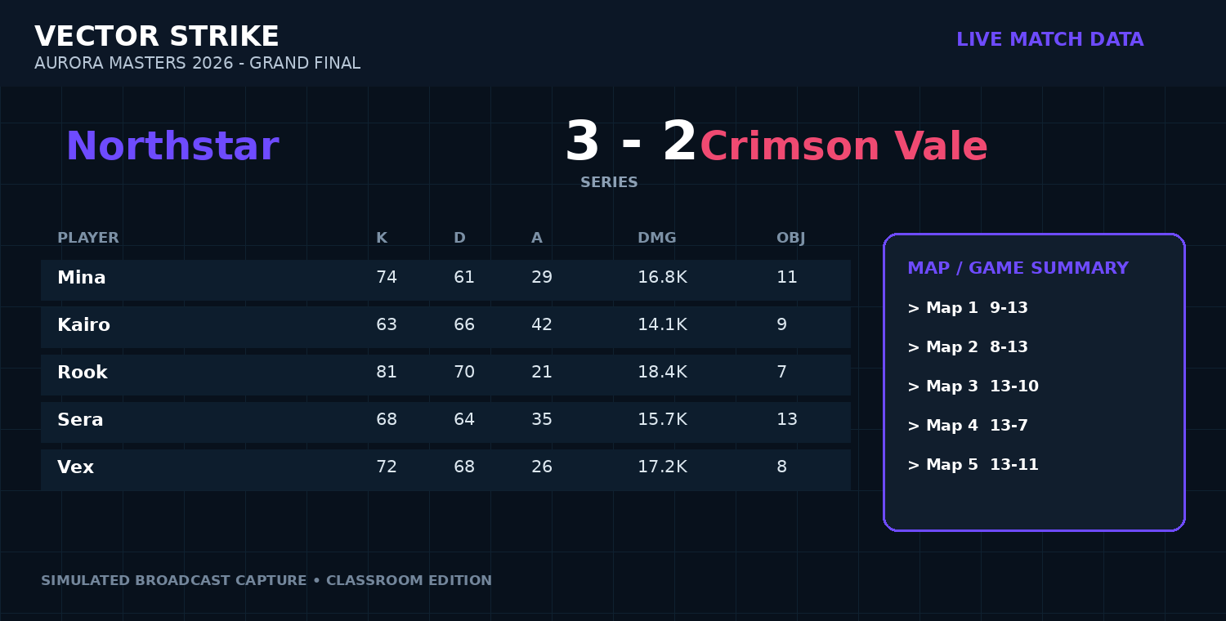
Broadcast-style match data panel (simulated from the report dataset).

DATA ROOM: WHAT THE NUMBERS SHOW
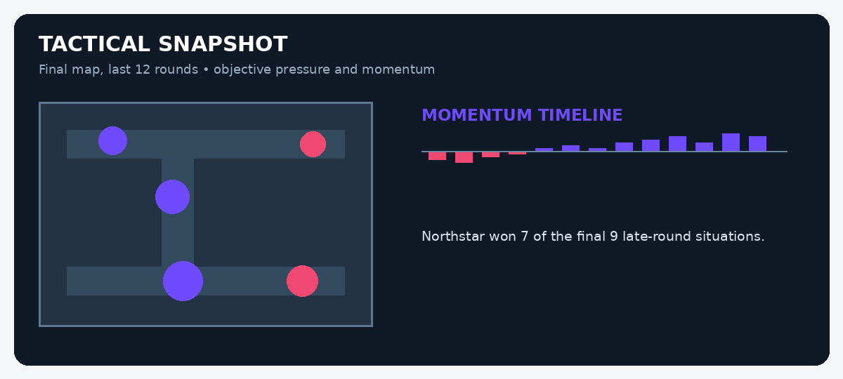
MATCH EVIDENCE BOARD
Evidence | Recorded figure | What it may suggest
Series score | Northstar 3-2 Crimson Vale | Northstar recovered after losing the first two maps.
Late-round record | 7 wins from 9 | Could indicate strong decision-making under time pressure.
Total eliminations | Crimson Vale +6 | The losing team can still lead a headline stat.
Defensive win rate, Map 4 | 71% | Northstar’s adjustment was especially effective on defence.
STUDENT INVESTIGATION: FACT OR INFERENCE?
Read the report and inspect the data panels. A FACT is directly stated or shown in the evidence. An INFERENCE is a reasonable conclusion drawn from that evidence. Do not treat a confident-sounding sentence as fact unless the report proves it.
Statement | Fact / inference? | Evidence you used | How certain are you?
Northstar won the tournament final.
Crimson Vale were the more skilful team mechanically.
Mina produced the final clutch of the series.
Northstar changed their approach after Map 2.
Kairo was the most important player in the final.
Crimson Vale had more total eliminations across the series.
Northstar handled pressure better than Crimson Vale.
Map 4 was Northstar’s strongest defensive performance.
EXTENSION: Write a 120-150 word analyst paragraph explaining which team appears stronger overall. Use at least three facts, label two inferences, and include one alternative interpretation of the data.
Classroom simulation: teams, tournaments and game data in this report are fictional but designed to mirror professional esports reporting conventions.

