ESPORTS INSIGHT • TOURNAMENT DESK | REPORT 02 | 02 JUL 2026
SOLARIS WIN THROUGH MAP CONTROL, NOT KILL COUNT
The champions lose two early teamfights yet dominate objectives, vision and late-game positioning.

Solaris | 3 - 1 | Apex Dynasty
EMEA champions | BEST OF FIVE | Pacific champions
Solaris lifted the World Rift Invitational trophy after a 3-1 final in which the scoreboard often looked closer than the map itself. Apex Dynasty secured first blood in all four games and led the kill count at 15 minutes in three of them.  Solaris responded by trading fights for structures. Across the series they claimed 31 towers to Apex Dynasty’s 18 and controlled 68% of major neutral objectives. Their support duo placed 214 vision wards, creating information advantages around the river before each decisive objective. | Game 3 offered the best example. Apex Dynasty held a 6-3 kill lead at 14 minutes, but Solaris had already taken the first two towers and both early objectives. At 27 minutes, Solaris used a side-lane push to force two defenders away, then secured the major boss uncontested.  The report can state that Solaris controlled more objectives and structures. It cannot prove that Apex Dynasty were 'outsmarted' without further evidence about communication, preparation and individual decision-making. That difference between what the numbers show and what they imply is central to reading esports analysis carefully.
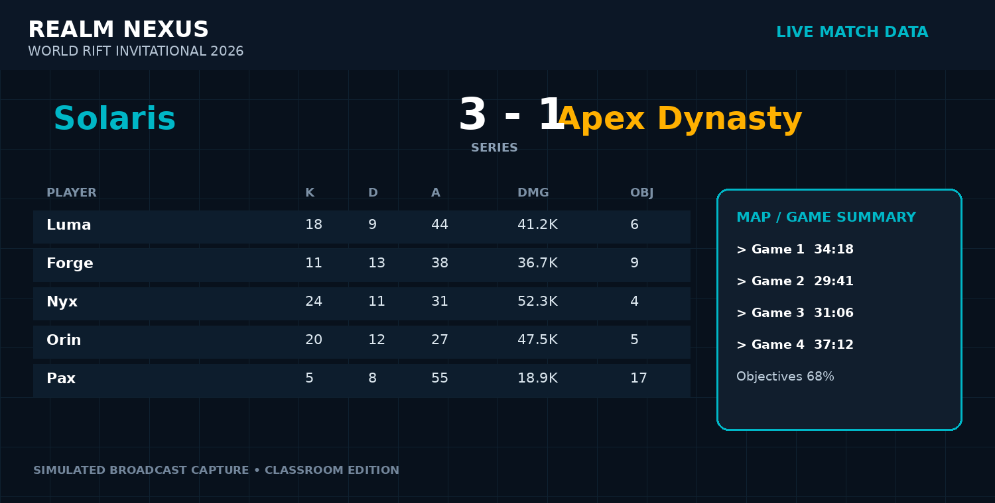
Broadcast-style match data panel (simulated from the report dataset).

DATA ROOM: WHAT THE NUMBERS SHOW
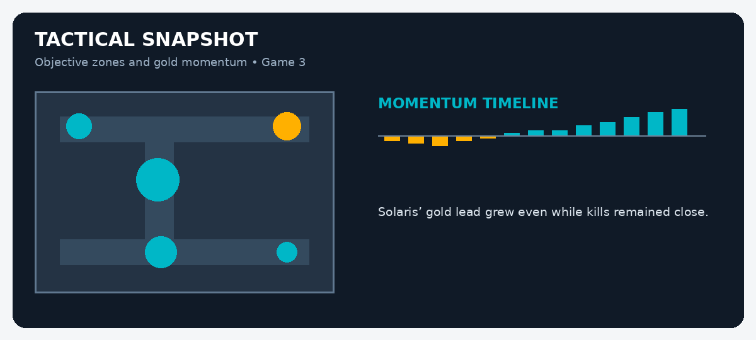
MATCH EVIDENCE BOARD
Evidence | Recorded figure | What it may suggest
Towers | 31-18 Solaris | Solaris converted map pressure into permanent objectives.
Major objectives | 68% Solaris | They controlled more high-value neutral objectives.
First bloods | 0-4 | Solaris often recovered after losing the first fight.
Vision wards | 214 | Information control was a significant part of their approach.
STUDENT INVESTIGATION: FACT OR INFERENCE?
Read the report and inspect the data panels. A FACT is directly stated or shown in the evidence. An INFERENCE is a reasonable conclusion drawn from that evidence. Do not treat a confident-sounding sentence as fact unless the report proves it.
Statement | Fact / inference? | Evidence you used | How certain are you?
Solaris won the final 3-1.
Apex Dynasty were poor at macro play.
Solaris took more towers.
Solaris deliberately allowed first bloods.
Vision control contributed to Solaris’ objective setup.
Game 3 lasted 31 minutes and 6 seconds.
Solaris were more intelligent than Apex Dynasty.
The kill count alone would give an incomplete picture of the series.
EXTENSION: Write a 120-150 word analyst paragraph explaining which team appears stronger overall. Use at least three facts, label two inferences, and include one alternative interpretation of the data.
Classroom simulation: teams, tournaments and game data in this report are fictional but designed to mirror professional esports reporting conventions.

