ESPORTS INSIGHT • TOURNAMENT DESK | REPORT 03 | 11 JUN 2026
IRONCLAD EDGE A THRILLER ON ECONOMY MANAGEMENT
A narrow 2-1 win is built on disciplined save calls, cleaner buy rounds and one dominant rifle performance.

Ironclad | 2 - 1 | Blue Orbit
Group A #1 | BEST OF THREE | Group B #2
Ironclad defeated Blue Orbit 2-1 in a final decided by small economic advantages rather than a huge gap in eliminations. The teams finished only four kills apart across 73 rounds, but Ironclad entered full-buy rounds more often and lost fewer players in rounds they had already decided to save.  That restraint mattered on the final map. Blue Orbit won five consecutive early rounds, yet Ironclad avoided repeated low-percentage purchases. By round 12, their economy had stabilised and they won six of the next seven full-buy rounds. | Rifle player Vale led the server with a 1.34 rating and 57% headshot rate. However, the series data also credits support player Ibis with 19 flash assists and the team’s lowest average equipment loss in defeated rounds.  It is reasonable to infer that Ironclad managed resources effectively. It would be less secure to claim that Blue Orbit 'panicked', because the report contains no direct communication evidence. Professional analysis often sounds certain, so readers need to test every conclusion against what is actually recorded.
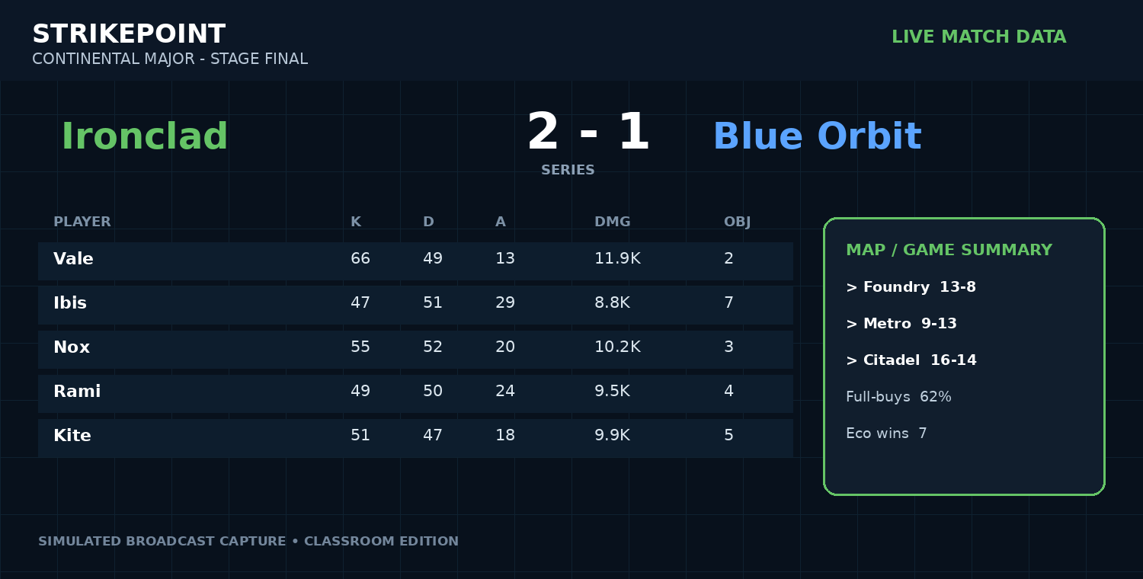
Broadcast-style match data panel (simulated from the report dataset).

DATA ROOM: WHAT THE NUMBERS SHOW
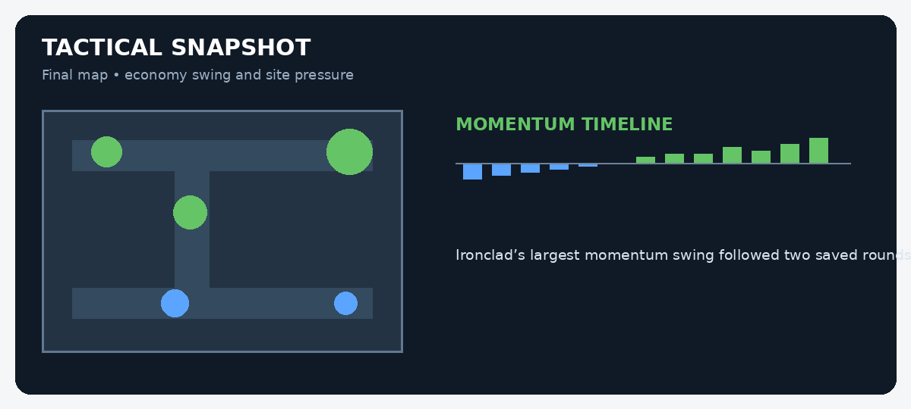
MATCH EVIDENCE BOARD
Evidence | Recorded figure | What it may suggest
Series kills | Ironclad +4 | The teams were closely matched in eliminations.
Full-buy rounds won | 62% Ironclad | Their strongest results came with complete equipment.
Vale rating | 1.34 | Vale had the strongest individual statistical line.
Flash assists, Ibis | 19 | Support utility contributed directly to team fights.
STUDENT INVESTIGATION: FACT OR INFERENCE?
Read the report and inspect the data panels. A FACT is directly stated or shown in the evidence. An INFERENCE is a reasonable conclusion drawn from that evidence. Do not treat a confident-sounding sentence as fact unless the report proves it.
Statement | Fact / inference? | Evidence you used | How certain are you?
Ironclad won 2-1.
Blue Orbit panicked after losing their lead.
Vale had a 57% headshot rate.
Ironclad used save rounds effectively.
Ibis was more valuable than Vale.
The teams were separated by only four kills.
Economy management was relevant to the result.
Ironclad would win a rematch.
EXTENSION: Write a 120-150 word analyst paragraph explaining which team appears stronger overall. Use at least three facts, label two inferences, and include one alternative interpretation of the data.
Classroom simulation: teams, tournaments and game data in this report are fictional but designed to mirror professional esports reporting conventions.

