ESPORTS INSIGHT • TOURNAMENT DESK | REPORT 05 | 09 APR 2026
EMBER CREW WIN TITLE WITHOUT THE MOST ELIMINATIONS
Placement points, rotation timing and late-game survival outweigh raw aggression across twelve matches.

Ember Crew | 186 - 177 | Rift Wolves
Final standings #1 | 12-MATCH FINAL | Final standings #2
Ember Crew won the World Survival Finals by nine points despite recording fewer eliminations than runners-up Rift Wolves. Across twelve matches, Ember collected 69 elimination points and 117 placement points. Rift Wolves produced 81 elimination points but only 96 from placement.  Ember reached the final eight teams in ten of twelve matches and placed inside the top three six times. Their route choices were usually made before the fourth zone closed, reducing the distance they had to travel through contested areas later. | Match 11 created the decisive gap. Rift Wolves earned eight eliminations but exited in 13th place after a contested rotation. Ember recorded only three eliminations, survived to second place and scored 18 total points from the match.  The data proves that Ember scored more placement points and survived deeper into more matches. It supports an inference that their tournament strategy prioritised consistency. It does not prove that they were 'less brave' or that Rift Wolves were reckless; those are value judgements requiring evidence beyond a scoreboard.
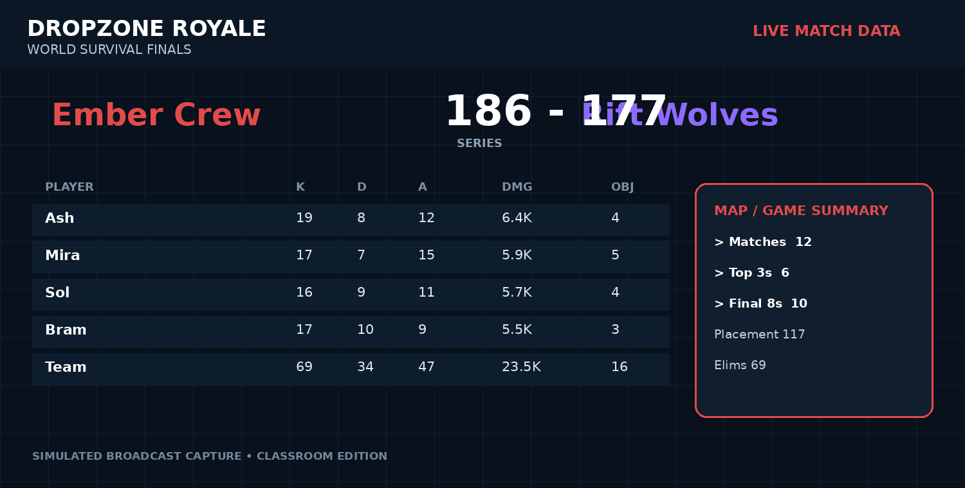
Broadcast-style match data panel (simulated from the report dataset).

DATA ROOM: WHAT THE NUMBERS SHOW
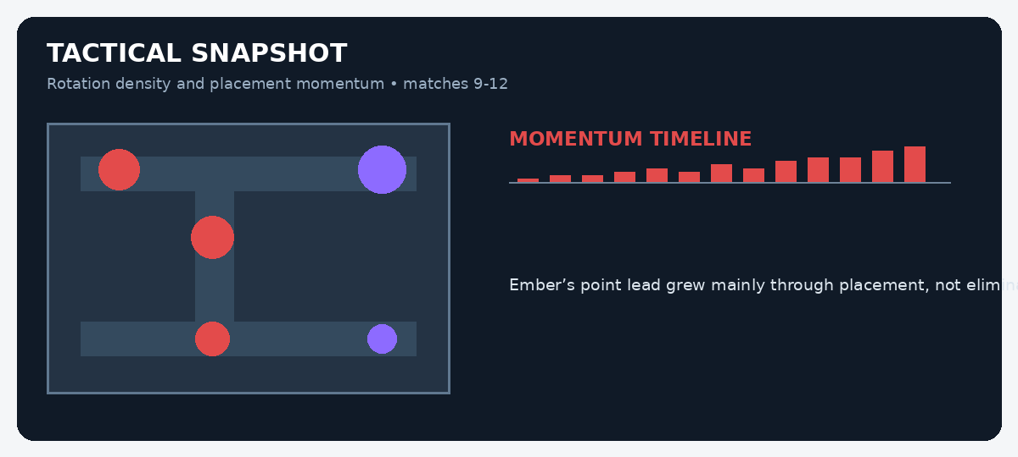
MATCH EVIDENCE BOARD
Evidence | Recorded figure | What it may suggest
Final points | 186-177 Ember | Ember won the event by nine points.
Elimination points | Rift Wolves 81 | The runners-up were more productive in eliminations.
Placement points | Ember 117 | Survival position supplied most of Ember’s advantage.
Top-three finishes | 6 | Ember repeatedly reached the closing stages.
STUDENT INVESTIGATION: FACT OR INFERENCE?
Read the report and inspect the data panels. A FACT is directly stated or shown in the evidence. An INFERENCE is a reasonable conclusion drawn from that evidence. Do not treat a confident-sounding sentence as fact unless the report proves it.
Statement | Fact / inference? | Evidence you used | How certain are you?
Ember Crew won by nine points.
Rift Wolves were the more aggressive team.
Ember had fewer elimination points.
Ember’s strategy prioritised consistency.
Rift Wolves were reckless.
Ember reached the final eight in ten matches.
Match 11 was important to the final points gap.
Ember would have lost under an elimination-only scoring system.
EXTENSION: Write a 120-150 word analyst paragraph explaining which team appears stronger overall. Use at least three facts, label two inferences, and include one alternative interpretation of the data.
Classroom simulation: teams, tournaments and game data in this report are fictional but designed to mirror professional esports reporting conventions.

