ESPORTS INSIGHT • TOURNAMENT DESK | REPORT 04 | 24 MAY 2026
VELOCITY TURN DEFENCE INTO ATTACK IN 4-2 FINAL
Goal-line saves and immediate counter-attacks define a fast, high-scoring championship series.

Velocity | 4 - 2 | Nova Union
Circuit points #3 | BEST OF SEVEN | Circuit points #1
Velocity won the Global Circuit Championship 4-2 after producing the event’s strongest defensive numbers in the final. Nova Union actually took more shots, 58 to 49, but Velocity goalkeeper Arco recorded 31 saves and the team converted defensive clearances into 14 shots within six seconds.  The biggest swing came in Game 5. Nova Union held 63% territorial pressure but failed to score. Velocity won 2-0, with both goals beginning from saves inside their own defensive third. | Across the series, Velocity scored on 22% of shots compared with Nova Union’s 14%. They also won 61% of contested aerial touches in midfield, reducing the number of second-chance attacks Nova Union could create.  Those figures support the inference that Velocity were efficient and dangerous on the counter. They do not prove that Nova Union attacked badly: a high shot total can indicate sustained pressure, while a low conversion rate may reflect excellent goalkeeping, poor finishing, difficult shot selection or a mixture of all three.
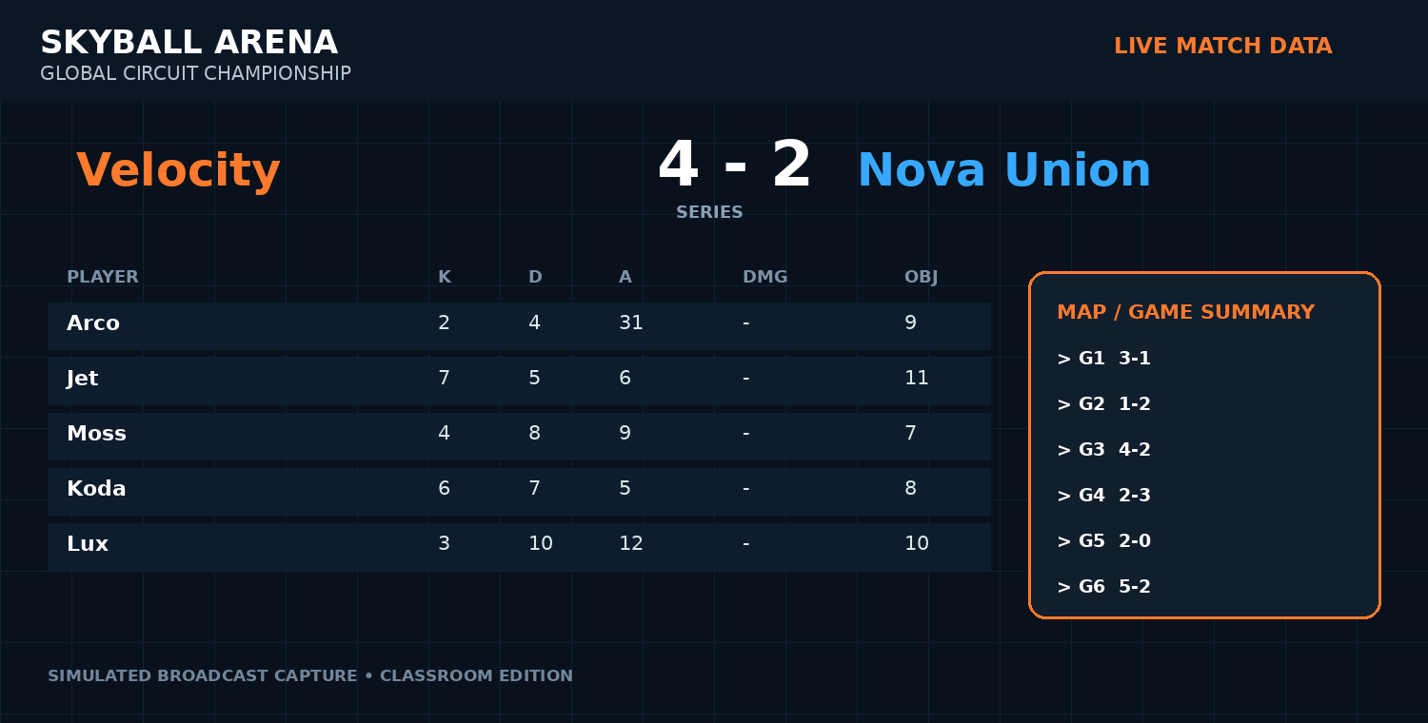
Broadcast-style match data panel (simulated from the report dataset).

DATA ROOM: WHAT THE NUMBERS SHOW
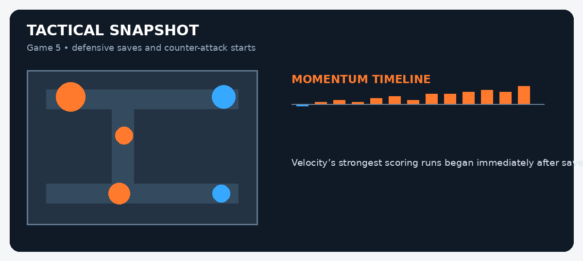
MATCH EVIDENCE BOARD
Evidence | Recorded figure | What it may suggest
Shots | Nova Union 58-49 | Nova Union generated more attempts.
Save total, Arco | 31 | Velocity’s goalkeeper was heavily involved.
Shot conversion | Velocity 22% | Velocity turned a higher share of shots into goals.
Aerial contests | 61% Velocity | They controlled more midfield aerial challenges.
STUDENT INVESTIGATION: FACT OR INFERENCE?
Read the report and inspect the data panels. A FACT is directly stated or shown in the evidence. An INFERENCE is a reasonable conclusion drawn from that evidence. Do not treat a confident-sounding sentence as fact unless the report proves it.
Statement | Fact / inference? | Evidence you used | How certain are you?
Velocity won the championship.
Nova Union were the more attacking team.
Arco made 31 saves.
Velocity were more clinical in front of goal.
Nova Union chose poor shots.
Game 5 ended 2-0.
Velocity’s counter-attacks were effective.
Nova Union deserved to win because they had more shots.
EXTENSION: Write a 120-150 word analyst paragraph explaining which team appears stronger overall. Use at least three facts, label two inferences, and include one alternative interpretation of the data.
Classroom simulation: teams, tournaments and game data in this report are fictional but designed to mirror professional esports reporting conventions.

